Solid Phase Extraction SOP
Katie Wampler
Before Collecting Samples
- Use the SPE worksheets attached to record the weight of the dry bottles with the caps. Put the weight on a piece of tape and put on the bottle. Also record the bottle number and weight on the worksheet.
Filter Samples
- Collect 1-2L of sample in an acid washed HDPE bottle.
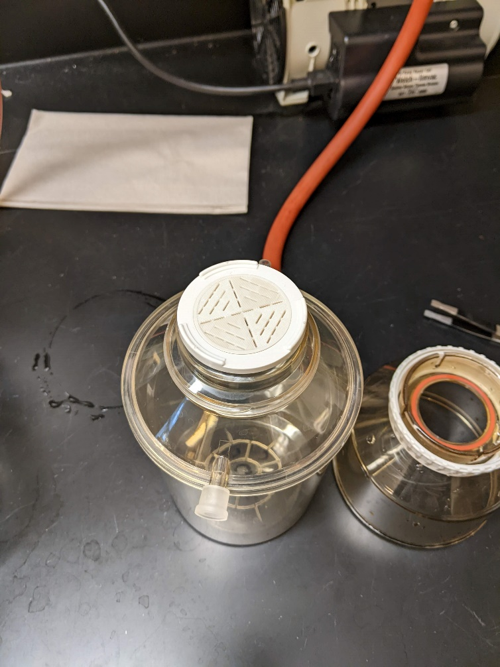
- Within 24 hours of sample collection, filter the sample with a 0.2 um PES filter. If samples are visibly turbid, prefilter with a 0.45 um filter first.
- Use the filter setup in Richardson 273 by the sink, the filtering materials should be in the cabinet above the setup.
- Ensure units and forceps have been rinsed 5 times with DI water before use.
- Place the white disk on top of the receiving chamber, ensure it’s seated. Using forceps, place the filter paper on top of the disk. Place the funnel on top and press down to keep it seated while screwing in tightly. If the sample is marked as turbid use a 0.45 um filter, otherwise use a 0.2 um filter.
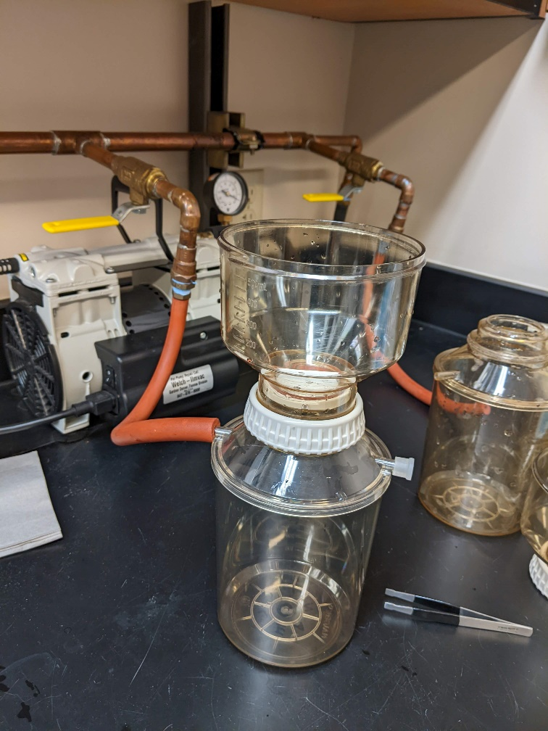
- Place the vacuum hose on the open arm that is not capped, adjust the positioning of the apparatus so it can stand up by itself.
- Open the line by turning the yellow lever perpendicular to the wall. Pour in a small amount of sample (~50 mL). Ensure the sample bottle is next to the apparatus so you know which sample is which.
- Repeat for all four apparatuses.
- Once all are setup, turn on the vacuum pump, keep an eye on the pressure, it should not go above 30 in Hg (aim for 25).
- Let the water drain through the paper, once pretty much through for all the samples, turn off the vacuum. Swirl the sample in the receiver to wash, use the side arm to drain the water into the sink. Reconnect to the vacuum. Repeat for all four sets.
- Pour in more sample for each and turn on the vacuum. Keep adding sample until the whole bottle is filtered or the filter paper gets clogged and needs to be switched out.
- Once the whole bottle has been filtered, turn off the vacuum. Use the side arm to pour a small amount of filtered sample into the original bottle. Cap and swirl to rinse. Repeat 3 times, dumping in between. After bottle has been rinsed, pour the rest of the sample into the bottle.
- If you used a 0.45 um filter, repeat filtration of the sample using a 0.2 um filter.
- Between unique sites, rinse apparatus with DI water 5 times.
- Once samples have been filtered, pull ~100 mL for DOC and EEM’s analysis, using an acid washed 125mL HDPE bottle, rinse 3 times with sample before filling. Label 125 mL bottle and put all samples in the fridge.
Acid Washing Tubing and Caps
- Rinse tubing and caps with DI water. Make sure that DI water flows inside the tubing. It's easier to hold the tubes in a bunch in your hand under the DI water.
- The caps can be put into the 10% HCI acid bath for approximately one hour. DO NOT leave them in longer, or the plastic will start to degrade.
- Remove the caps from the acid bath with gloved hands, and then rinse in DI water.
- Place on a kimwipe and cover with another kimwipe to dry.
- Using the 10% HCI squirt bottle and waste container, loop the tubing once in your hand and place the squirt tip into one end of the tubing, making sure to catch the flow through in the waste container. It's good to get a few seconds of flow without bubbles in the tubing to ensure adequate acid contact occurs inside the tubing. 10% HCl is in a container below the hood in 273.
- Rinse the tubing again in DI water, and then place on the drying racks to dry.
To Do the Day Before
- Make sure you know the weight of your empty container, this should be on the SPE worksheet.
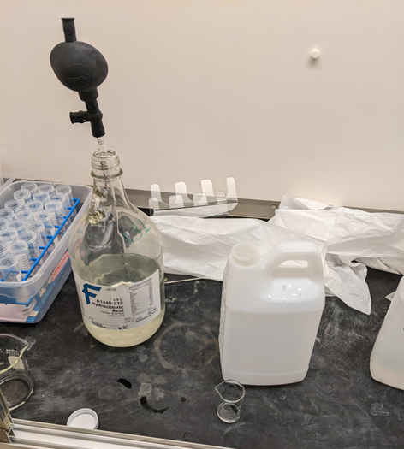
- Weigh your sample, record on the worksheet.
- Add concentrated HCl to each sample to acidify:
  - Add 1uL HCI per 1g sample.
  - Example: Sample weight = 150g add 150uL of HCI
  - Acid is in Richardson 273 below the hood. Put acid in the hood, being very careful. Wear face shield, gloves, and lab coat. If any acid gets on gloves immediately discard gloves and wash hands thoroughly.
  - Look for a glass pipet and bulb in the drawers across from the hood. Press the “A” while squeezing the bulb to start, then use the “S” to pull suction. Using a clean beaker from the cabinet (should be covered in foil), put just slightly more acid than needed in a small beaker. Use the “E” to dispense liquid. The pipet can stay in the acid while working.
  - Using the 1000 uL volumetric pipet by the Aqualog, using a clean tip to add the acid.
  - Once done, carefully pour any extra acid into the acid waste container on the counter.
  - Using a secondary container, transfer the beaker and pipet to the sink to rinse thoroughly with DI water. Let dry by the sink.
  - Cap the acid and put back under the hood.
- Shake thoroughly after adding acid.
- Store in refrigerator overnight to equilibrate.
Setting Up the Manifold, Prepping Cartridges and Filtering Sample
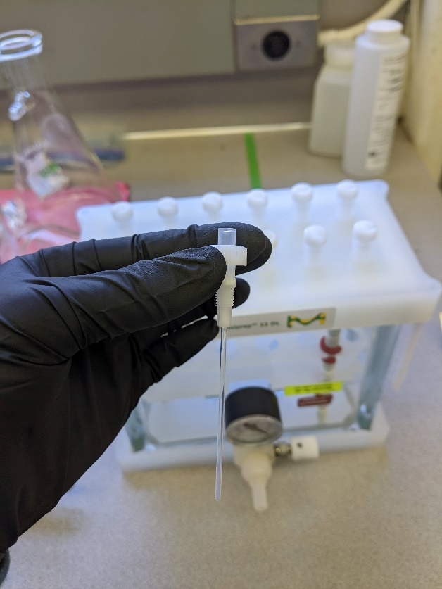
- **Before starting, check the pH of each of your samples using filter paper. They need to have a pH of 2 and should have been acidified the day before. This is also a check to make sure that you didn't miss one. To do this, shake the bottle and open. Dip a small piece of pH paper in the cap with sample in it. Check the color.
- Bring the acidified samples over to Oak Creek to extract.
- Pull the manifold out of the middle cabinet in Oak Creek.
- Insert the plastic liner needles into the valves. Be careful to not bend or pinch them, they are very easy to pinch, and they will not allow flow to pass through. Screw the valves into the manifold. They should be a little looser than finger tight.
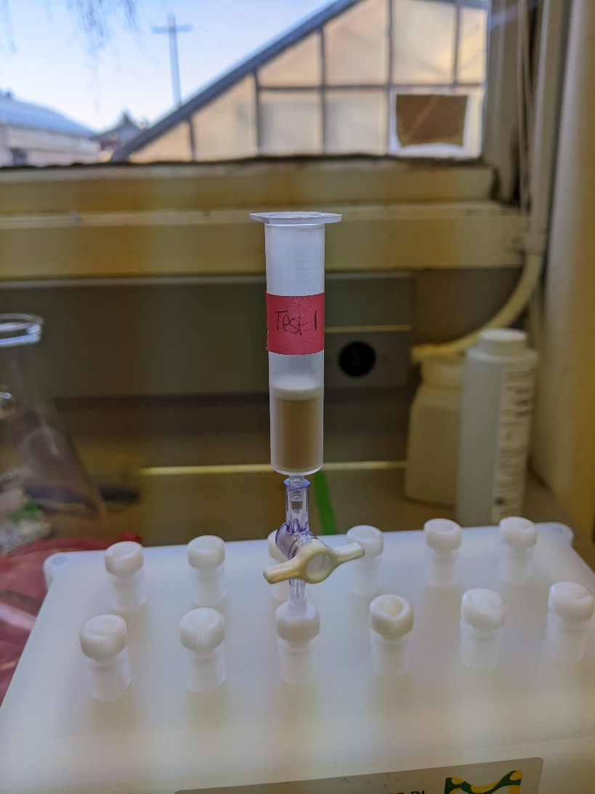
- Insert the stop cocks into the needles. Some stop cocks there is a bottom leur lock thing that will spin down onto the needle and make the connection a little more secure, and some just stick in. Turn the stop cocks to the closed position.
- Insert the cartridges into the top of the stop cocks. No need to set up the vacuum at this time.
- Make sure that your cartridges are labeled with the sample number before starting.
- If the white tube rack is in the manifold, remove it before starting.
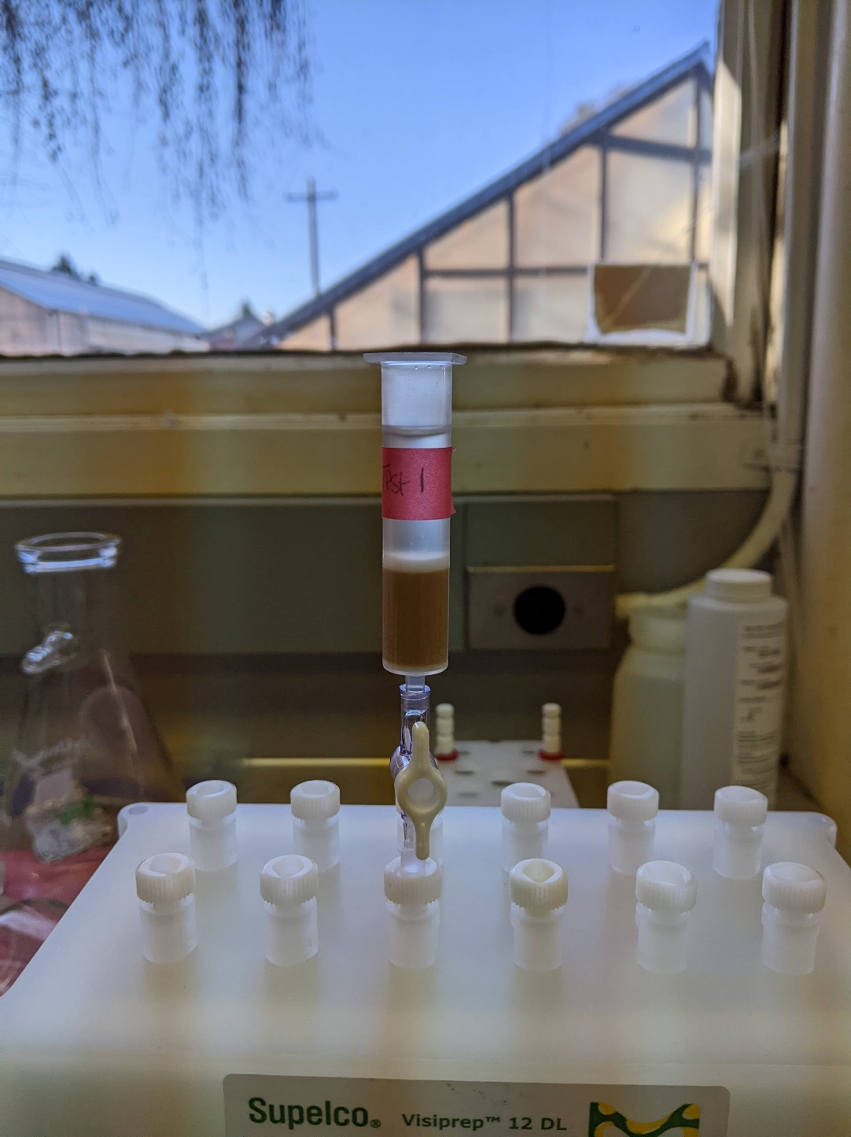
- First, the cartridges are conditioned using LC/MS or Optima grade methanol. Open the stopcocks and add 6mL of MeOH to each cartridge at a time using a volumetric pipet and beaker and let the solvent drain under gravity. Repeat once more for a total of 12mL MeOH added. Once the final volume drains, close the stop cock immediately. Once finished, remove the cartridge rack and pour out the MeOH waste into the MeOH waste container. If you forget to do this you will be mixing MeOH and acid waste together.
  - Don't forget to condition the pipette tip 3-4 times with MeOH before pipetting
  - Try to not let the cartridge drain completely before adding the next 6mL
- Next, equilibrate the cartridges using 0.01M HCI. Add 6mL of 0.01M HCI to each cartridge and let the solvent drain under gravity. Repeat three times, for a total of 18mL of 0.01M HCI added. Once the volume has drained from each cartridge, close the stop cocks.
  - The equilibration solvent matches the matrix of the sample.
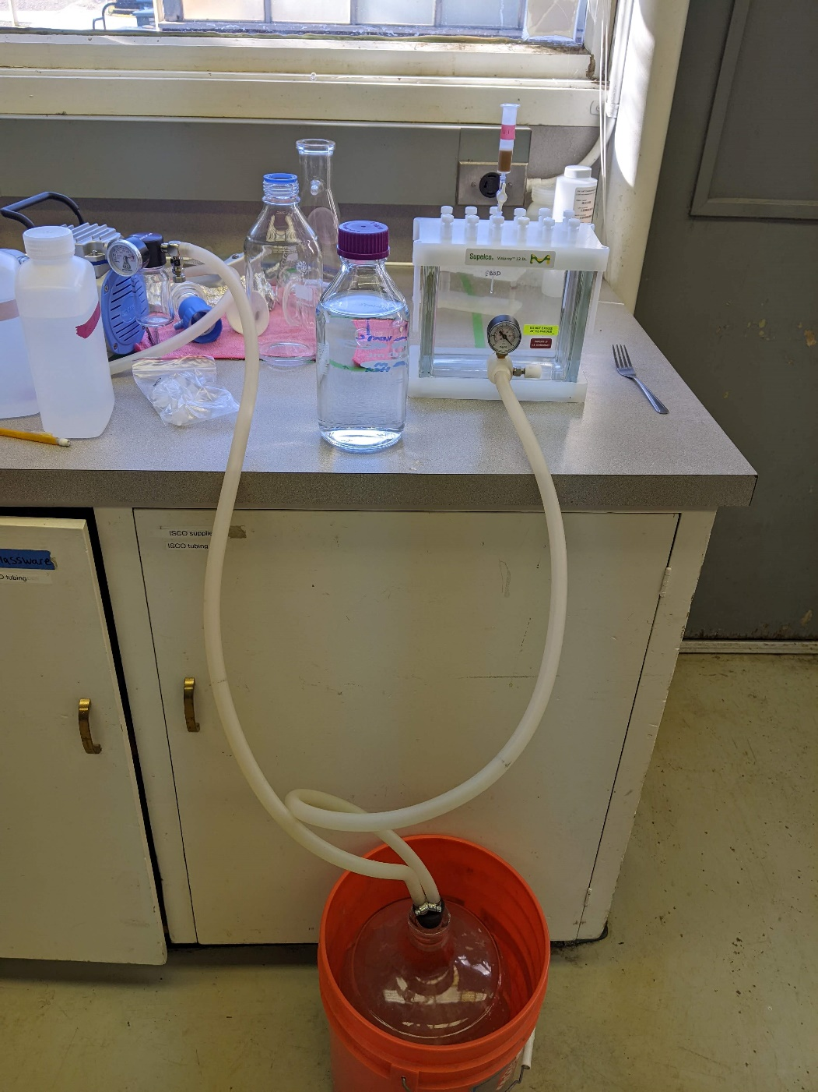
  - Add 4mL of 0.01M HCI to each cartridge, keeping the stop cock closed.
  - This will be to make sure that the cartridge doesn't dry out when you turn the vacuum on
- Snap in the caps to the cartridges. Some liquid will squirt out, and that's okay. The red caps are the best. The clear caps are harder to remove, so it's best to put those ones in the front row on the rack.
- Now you must arrange your samples around the manifold. Remember to try and put the sample bottles close to their matching cartridge. Elevating the sample bottles using cent tube racks is recommended.
- Insert the tubes into the top of the caps, putting the end of the tube into the sample bottle.
  - Try to minimize the tangling of tubes
  - Some tubes will need to be taped in place
  - Be careful to not knock over anything!
- Now assemble the vacuum. Place the black stopper into the top of an empty glass carboy. The tube that has the longer end in the black stopcock attaches to the manifold. The tubing with the end that does not extend past the black stopcock attaches to the vacuum. Have the regulator knob in the front open to start.
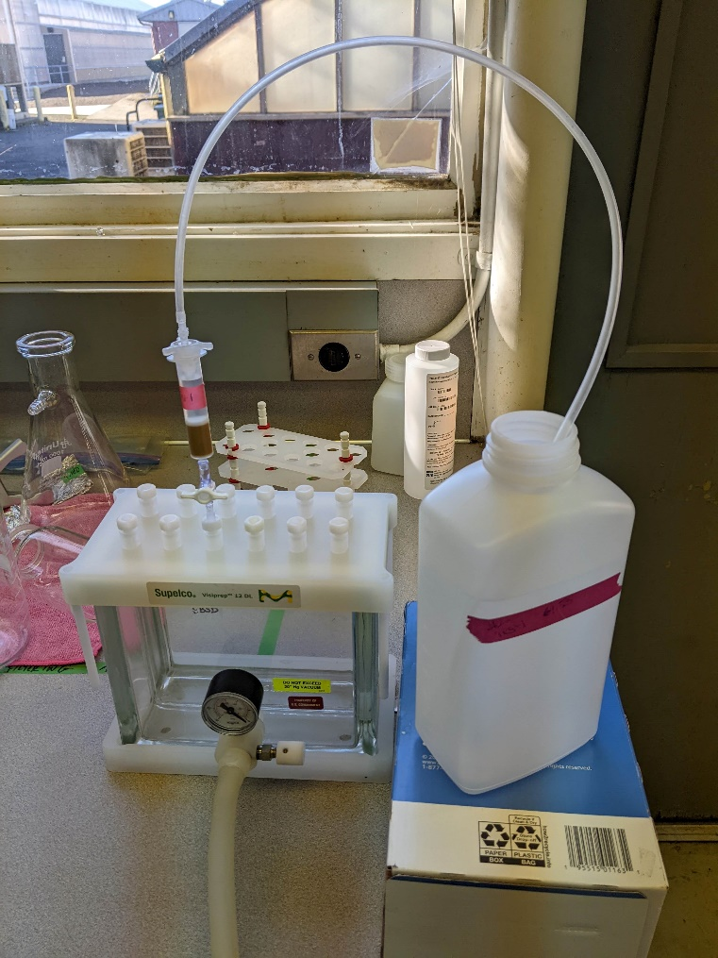
- Turn on the vacuum. Watch the pressure on the regulator in the front. The pressure must not exceed ~20 inHg. You can use the regulator knob to open the vacuum a bit to decrease the pressure.
- Open the stop cocks. Watch the drip speed of each cartridge. You don't want the drop rate to exceed 5 drops per second. It will take a few minutes to get all the stop cocks opened and dripping at the right rate. Record your start time.
- Periodically check on the water volume in each sample bottle. From the start you can typically walk away for an hour and be safe.
- When a bottle is almost dry, lift the bottle up and help the tube suck up the final bit of liquid. Then raise the tube and watch the last of the liquid drop into the cartridge. Turn the stop cock closed and record the end time.
  - You can remove the bottles and cap them after they are done
  - You can also remove the cartridge cap with the tube once they are done.
- Before the cartridges are dried, they must be acidified. Using the same 0.01M HCI that you equilibrated with, work in the same 6mL increments, adding a total of 12mL. You will have to turn the stop cock back on and want the same rate of dripping as before.
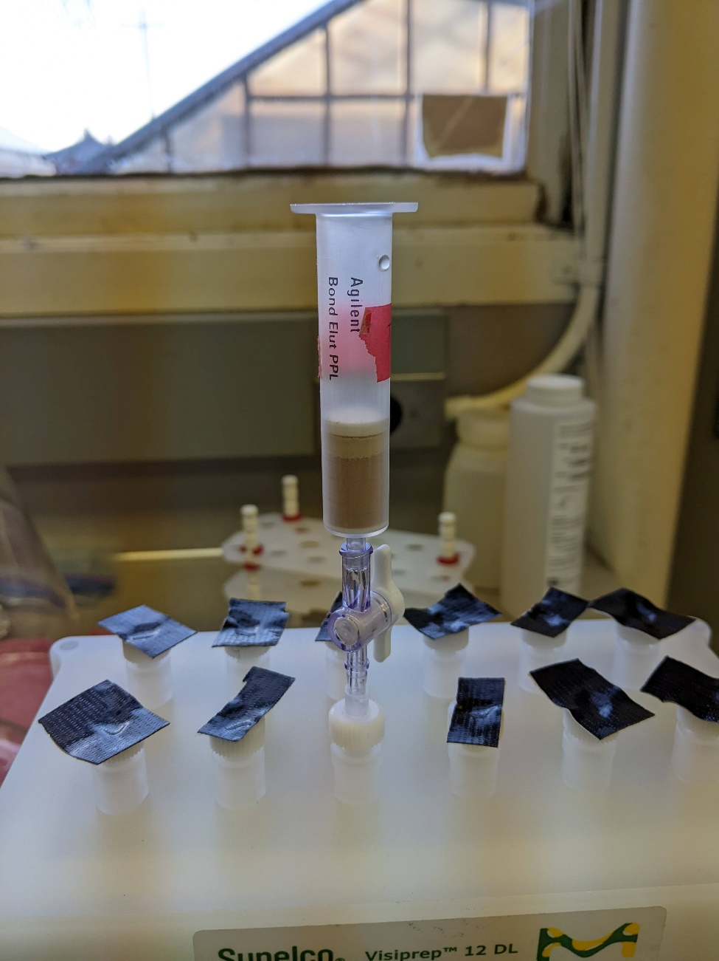
  - You can add more acid as soon as the last 6mL is almost drained
  - If your flow rate is too high and the rinse solvent rips through the column (sometimes it happens), you can add another 6mL's of acid for another rinse
- Once ALL of your cartridges have been acidified, you can open all of the stop cocks and allow the cartridges to dry.
  - This will most likely take 3-4 hours
  - What to look for in a dry cartridge
    - First, any remaining water in your cartridge will give you awful water peaks in your spectra and no one wants that
    - When the cartridges begin to dry out, you'll notice a horizontal moisture line through the resin. A fully dried cartridge does not have a noticeable line
    - A fully dried cartridge should be totally uniform in color
- Once your cartridges are dry, put them each in individual bags with their liner needles and stop cocks. You will use them again when eluting
  - If you need to dry the cartridges more the following day, you can hook up the outflow waste directly to the benchtop flask instead of to the large glass carboy.
  - Store the bagged cartridges in the fridge until eluting.
Eluting
- Label and pre-weigh 15mL falcon tubes for the eluted sample.
- Set up your manifold and place the liner needles into the open valves (you might have to open them again). Using the same Optima grade MeOH, squirt MeOH into each liner needle to wash out any contaminants. Let drain under gravity and repeat two more times.
- After cleaning the needles, use the vacuum very quickly to remove most of the moisture from the needles.
- Place the falcon tube rack into the glass housing. Place the falcon tubes into the rack in the coordinating position of their respective liner needles. Make sure that the tubes are in the little depression in the bottom of the rack and that they are straight.
  - The rack has a directionality to it. It only fits one way!
- Place and rack on top of the glass housing, making sure that each needle goes inside of the falcon tubes. None of the needles should be touching the side of the tube.
- Now you can insert your cartridges into their respective liner needles with the stop cocks.
- Use the fancy weighing spatula to evenly push the filters back down so that there is space. between the filter and the sorbent. Make sure to clean the spatula with MeOH in between each cartridge
  - But don't dip a dirty Kim wipe into your beaker of nice clean MeOH!
  - Do a final check that everything is aligned properly.
- The total volume of eluent is 6mL of Optima grade MeOH. Add the MeOH in two increments of 3mL. It is easiest to add 3mL to all cartridges, and then turn the stop cocks to the on position.
  - Eluting is done under gravity.
- Once all the eluent has been added, turn on the vacuum for a few seconds to remove the last of the liquid. MeOH is volatile, so start with the vacuum open and then slowly increase the pressure. You're only looking for most of the liquid to come out. This should happen very quickly, and then immediately turn off the vacuum.
- Now you're done eluting! Cap your falcon tubes and weigh them, recording the post weight. Store the cartridges in individual ziplock bags in the fridge. The falcon tubes are put in the -80C freezer.
TO PREPARE ACIDS
- To make more 10% HCl, use the directions above for dispensing concentrated acid. Use a clean 500 mL volumetric flask, fill mostly with DI water, leaving space for acid. Add 50 mL of concentrated acid then fill with DI water to the line using a clean pipet in a clean beaker. Cap and invert a few times before adding to the 10% HCl container below the hood.
- To make more 0.01 M HCl add 4.13 mL of 10% HCl to a 500 mL volumetric flask filled most of the way with DI water. After adding the 10% HCl finish filling with DI water to the line. Cap and invert a few times before pouring into the 0.01 M HCl bottle. This bottle is usually under the hood unless being actively used at Oak Creek to do samples.
Consumables
0.2 um Filters, Supor® Membrane, 0.2 µm, , Gridded, White, Gamma Irradiated, Bulk w/ Parchment Separators: https://shop.pall.com/us/en/products/disc-filters/zid66234?CategoryName=&CatalogID=&tracking=searchterm
0.45 um Filters, Supor® Membrane, 0.45 µm, 47 mm, White, Gridded, Gamma Irradiated, Bulk w/ Parchment Separators: https://shop.pall.com/us/en/laboratory/analytical-qc/mobile-phase-filtration-1/zid60043?CategoryName=mobile-phase-filtration-1&CatalogID=laboratory
Cartridges:
Needles:

